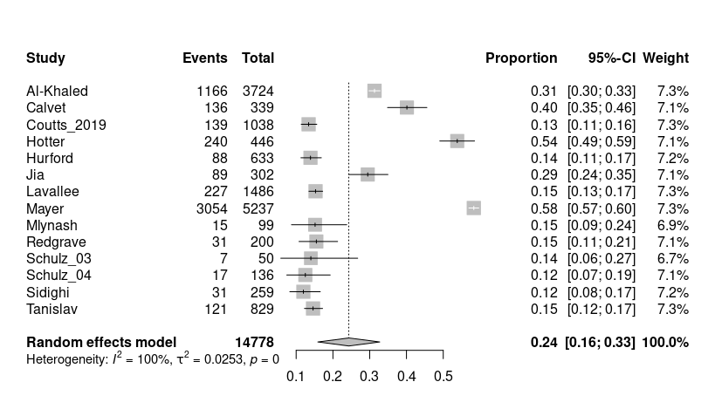
Figure 2. Forest plot of meta-analysis of pooled proportion of positive neuroimaging in clinically defined TIA patients.

